**Facial Expression Recognition Research**

Yingyan Shi

2018.5

**Facial Expression** are the most apparent and effective way to understand emotions, while **voice** and **gesture** can also convey some emotional information. Facial Expression Recognition is an important part of the field of affective computing.

**Affective computing** (sometimes called artificial emotional intelligence, or emotion AI) is the study and development of systems and devices that can recognize, interpret, process, and simulate human affects.

Facial Expression can be categorized into **seven basic emotions**:

Anger, disgust, fear, happiness, sadness, surprise and contempt.

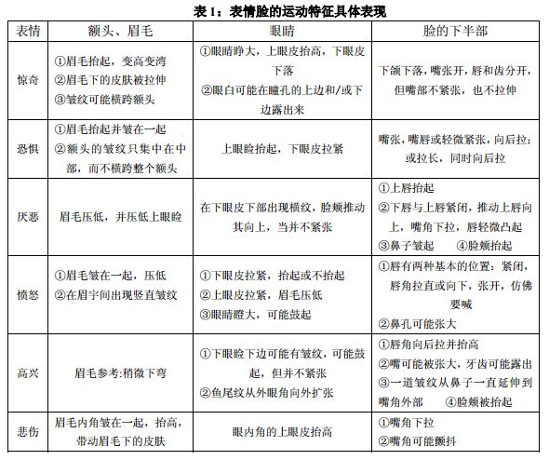

**Real World Applications:**

Human Computer Interaction

Driver Fatigue Surveillance

Medical Treatment

Real-time Mobile FER System

Rapid perceptual integration

Lie Detection

…

**Difficulties:**

Illumination variation, occlusions, non-frontal head poses, identity bias and the recognition of low-intensity expressions. The major challenge that deep FER systems face is the lack of training data in terms of both quality and quantity.

**Companies and Products:**

**Affectiva**, **AFFDEX APP** (available on Apple Store)

https://www.affectiva.com/

Affectiva have published some papers on its website about detecting complex and nuanced human emotions and cognitive states from face and voice, but without source code.

https://www.affectiva.com/science-resource/



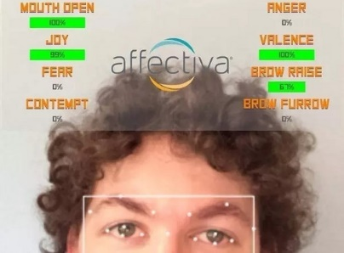

AFFDEX APP User Interface

**Facial Expression Databases**

|  |  |  |
| --- | --- | --- |
| dATABASE | SAMPLES | ACCESS |
| CK+ | 593 image sequences | http://www.consortium.ri.cmu.edu/ckagree/ |
| mmi | 740 images and 2,900 videos | https://mmifacedb.eu/ |
| jaffe | 213 images | http://www.kasrl.org/jaffe.html |
| tfd | 112,234 images | josh@mplab.ucsd.edu |
| fer-2013 | 35,887 images | https://www.kaggle.com/c/challenges-in-representation-learning-facial-expression-recognition-challenge |
| afew 7.0 | 1,809 videos | https://sites.google.com/site/emotiwchallenge/ |
| sfew2.0 | 1,766 images | https://cs.anu.edu.au/few/emotiw2015.html |
| mULTI-PIE | 755,370 images | http://www.flintbox.com/public/project/4742/ |
| BU-3DFE | 2,500 images | http://www.cs.binghamton.edu/~lijun/Research/3DFE/3DFE_Analysis.html |
| OULU-CASIA | 2,880 image sequences | http://www.cse.oulu.fi/CMV/Downloads/Oulu-CASIA |
| RAFD | 1,608 images | http://www.socsci.ru.nl:8180/RaFD2/RaFD |
| KDEF | 4900 images | http://www.emotionlab.se/kdef/ |
| EMOTIONET | 1,000,000 images | http://cbcsl.ece.ohio-state.edu/dbform_emotionet.html |
| raf-DB | 29672 images | http://www.whdeng.cn/RAF/model1.html |
| AFFECTNET | 450,000 images | http://mohammadmahoor.com/databases-codes/ |

In **posed** expression databases, the participants are asked to display different basic emotional expressions, while in **spontaneous** expression databases, the expressions are natural.

Facial expression recognition is a kind of image classification in nature. The whole **face expression recognition** research has been developed following the development of **face recognition**, and a better method in the face recognition field will be equally applicable to face expression recognition.

Based on the type of data, deep FER networks are divided into two main groups: **images based static facial expression recognition** and **video based emotion recognition**.

Almost all papers describe facial expression recognition algorithms **without** providing corresponding source code. There are several facial expression recognition projects based on convolutional neural networks on **GitHub**.

**Project on GitHub:**

Run successfully:

1. <https://github.com/Hanzhuo/Facial-Expression-Recognition-with-TensorFlow-Convolutional-Neural-Networks>

2. <https://sefiks.com/2018/01/01/facial-expression-recognition-with-keras/>

3. <https://github.com/a514514772/Real-Time-Facial-Expression-Recognition-with-DeepLearning>

4. <https://github.com/isseu/emotion-recognition-neural-networks>

5. <https://github.com/zlpure/Facial-Expression-Recognition>

Only model and weights

Not yet to run:

6. <https://github.com/dhvanikotak/Emotion-Detection-in-Videos>

**Reference:**

Shan Li & W. Deng, Deep Facial Expression Recognition: A survey (arXiv:1804.08348)

<http://arxiv.org/abs/1804.08348>

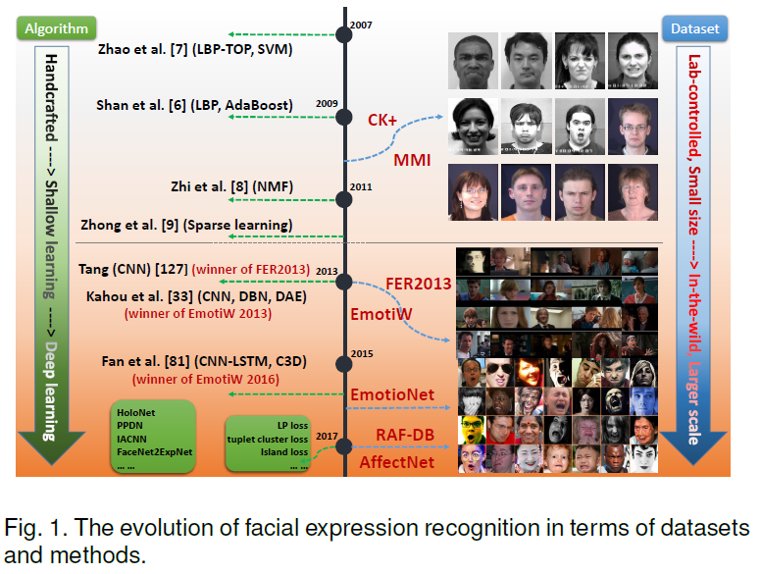

Three **main steps** are common in automatic deep FER:

1. Pre-processing
2. Deep feature learning
3. Deep feature classification
4. Pre-processing:
   1. Face alignment: detecting the face and then removing background and non-face areas.
   2. Data augmentation:
      1. Offline data augmentation: increasing the database. Rotation, translation, horizontal flips, scaling and sheer, changes in brightness and saturation.
      2. On-the-fly data augmentation: embedded in deep learning toolkits to alleviate overfitting.
   3. Face normalization:
      1. Illumination normalization: employing histogram equalization to increase the global contrast of images for pre-processing.
      2. Pose normalization: To yield frontal facial views for FER.
5. Deep networks for feature learning:
   1. Convolutional neural network (CNN)
   2. Deep belief network (DBN)
   3. Deep auto encoder (DAE)
   4. Recurrent neural network (RNN)
6. Facial expression classification
   1. The deep neural networks can perform FER in an end-to-end manner.
   2. Employing a deep neural network as a feature extraction tool and then applying additional classifiers, such as support vector machine (SVM) or random forest.

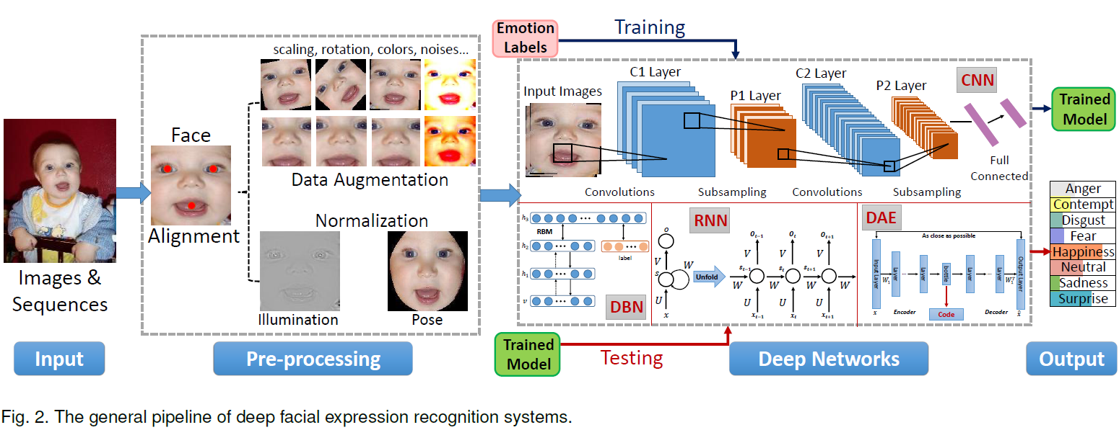

1. **Deep FER networks for static images**
   1. Pre-training and fine-tuning: face recognition (FR) datasets
   2. Diverse network input: diverse outstanding handcrafted features and their extension as the network input
   3. Auxiliary blocks & layers
   4. Network ensemble: the feature level and the decision level
   5. Multitask networks: FER and facial landmark localization
2. **Deep FER networks for dynamic image sequences**